**Shop Bridge Development Tracking**

|  |  |  |
| --- | --- | --- |
| **Sr. No.** | **Task** | **Time in Hrs.** |
|  | Backend Functionality | 6 |
|  | Frontend Functionality | 1 |
|  | Fronted Presentational aspects | 2 |
|  | Backend Fronted Integration | 2.5 |
|  | Unit Test Coverage | 3.5 |

Notes:

1. Download folder provided at github link
2. Download .mdf file and attach it to SQL database
3. Open the solution and run the project

Demo:

1. Start-up page

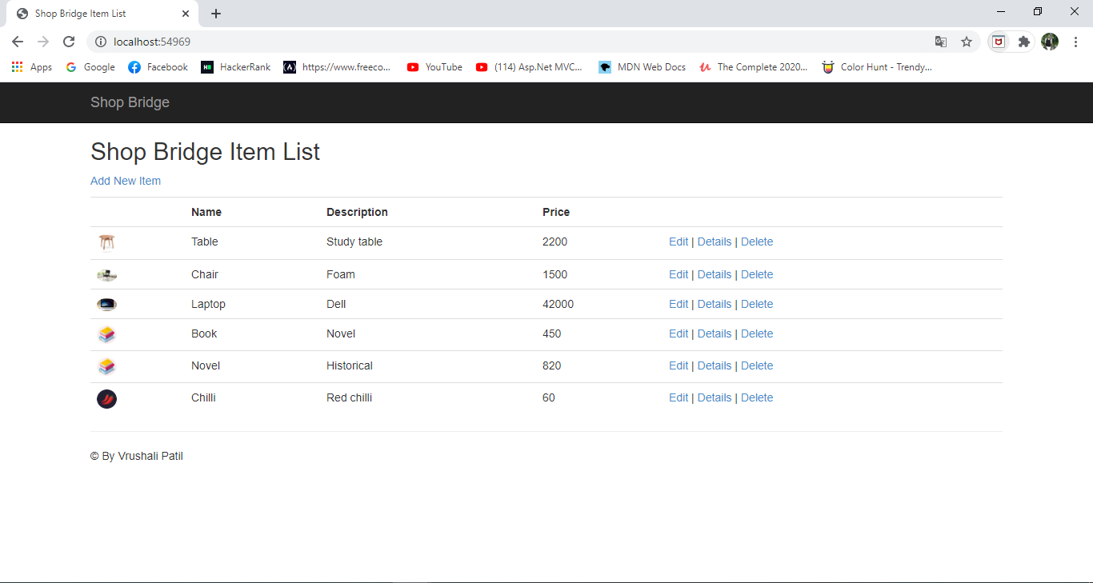

1. New item Add page

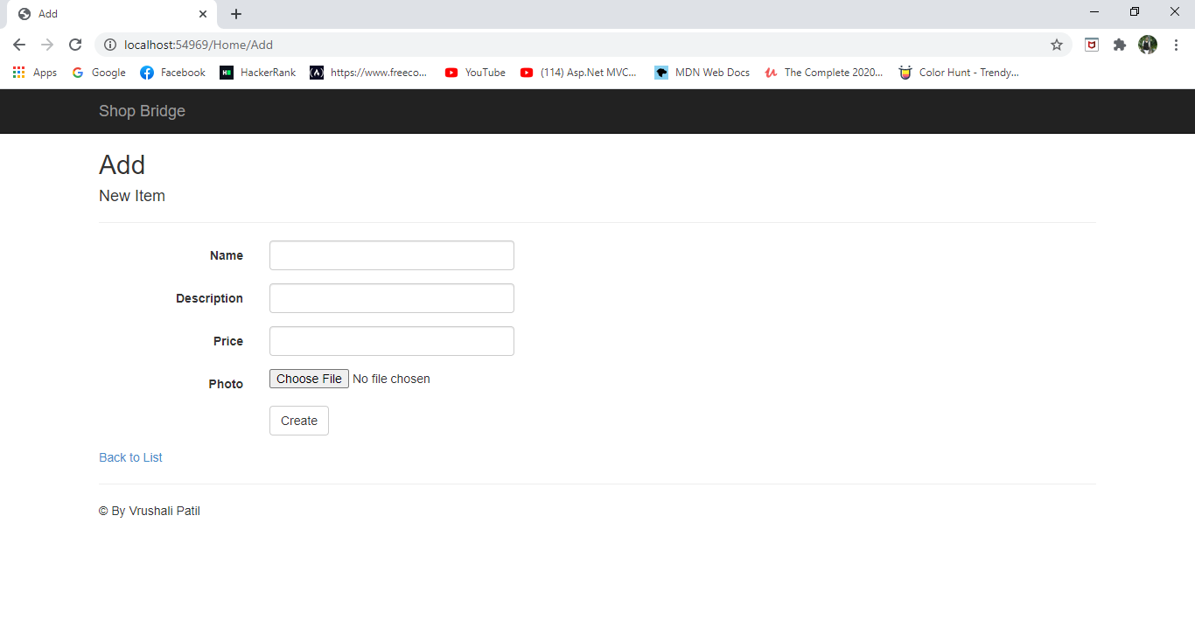

1. Edit Item Page

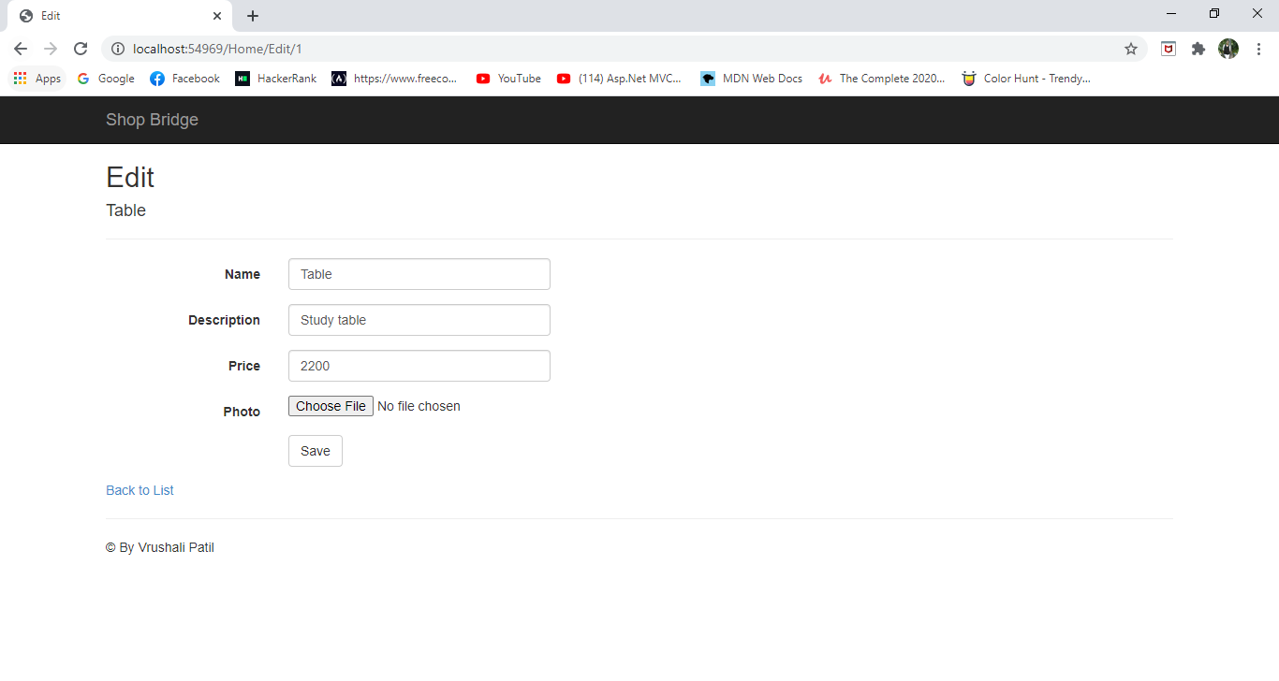

1. Details page

